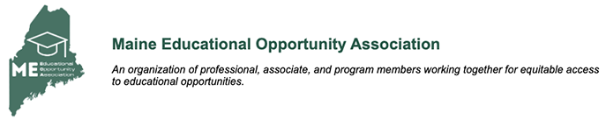
MEEOA Professional Development Funds Application
To apply for professional development funding, please fill out the application below. Funds can be up to $125. Please send your completed application to Sam Prosser (samantha.prosser@maine.edu) or Terry Charlton (tcharlton@cmcc.edu).

Applicant Name:
Applicant Program:
Applicant Institution:
Amount of professional development funds requested:

What professional development event/purpose is the applicant planning to use these funds?

Has the applicant applied for/received MEEOA Professional Development funds in the past? If so, what for?

